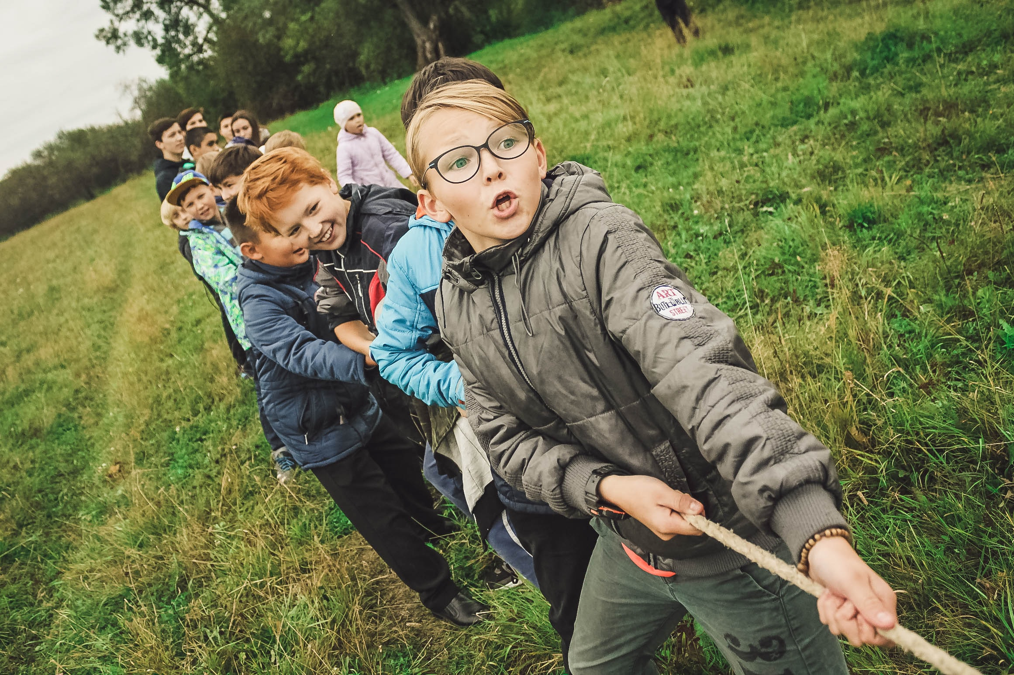

September 2024

SCHOOL SUCCESS PLAN

Martin Morigeau Elementary School

|  |  |
| --- | --- |
| Principal Message | |
| Martin Morigeau Elementary School is a rural K-7 school located on the traditional, unceded territories of the Ktunaxa and Secwépemc peoples. We also acknowledge that this area is chosen by the BC Métis Nation as home. Staff are committed to student engagement within the local area and working with community partners for inclusive, meaningful learning.  We strive for genuine connection to each other, the learning process, and our community.    Teachers, educational assistants, support staff and the Indigenous Education Support Worker have collaborated to develop this plan. We meet regularly, together with administration, to review recent data and monitor our progress toward our goals.  Throughout the year, opportunities for collaboration through classroom observations and discussions allowed teachers and administration to review process and adjust instruction to meet dynamic student needs.  Through Spring 2024 data review, teachers and support staff noted that continuing forward with our goal of increasing student achievement through formative assessment practices was justified.  Progress toward the School Success Plan is shared with the Parent Advisory Council throughout the year and an annual community engagement session open to all MMES community members each Spring. Feedback received is considered as support for the development of the annual plan and this cycle, parents requested clearer communication of student SEL supports and the school discipline process.    Crystal Woodworth |  |

|  |  |
| --- | --- |
| school demographics | |
| Staff  4 Classroom teachers  1 Learning Services Teacher/Teacher-librarian  3 Education Assistants  1 Indigenous Education Student Support Worker  1 Youth Care Worker  1 Admin Assistant  1 Principal | Students  69 students  30 Indigenous students |
| Grades  1 Kindergarten-1  1 Grade 2-3  1 Grade 3-4-5  1 Grade 5-6-7 |  |

|  |  |  |
| --- | --- | --- |
| Vision | Mission | |
| Our vision is to have a school where children flourish and reach their full potential as knowledgeable, caring, resilient, and contributing members of a global community. | Our mission is to meet the needs of each student through hands-on, experiential, place-based learning connected to our beautiful community. | |
| Values | | |
| At MMES we value:  Curiosity - having interest in learning new things.  Community – having a sense of belonging and care.  Character – being trustworthy and reliable. | |  |

|  |  |
| --- | --- |
| thematic narrative | |
| In the 2023-24 year, MMES staff focused on student achievement by making small adjustments in teacher and student practice based on ongoing reflective student feedback known as “formative assessment”.  Staff noticed that incorporating student feedback about their learning provides immediate feedback on whether students are grasping concepts and at what level. If done regularly, teachers are able to make adjustments to their instruction, develop next steps in learning, and address student needs in the moment.  Staff noted that following this process resulted in:   * Organized data that supported teacher reporting. * Increased comfort assessing student competencies across multiple subject areas, * Fewer surprises during independent summative assessments (such as a quizzes, tests, or final projects). * Teachers entering the reporting cycle with a clearer understanding of the student’s grade level performance on the 1-4 indicator cycle. * Evidence with quotes, photos, video collected and shared on Seesaw making reporting smoother and more individualized. * Shared formative and summative assessment on Seesaw, allowing parents real-time access to student learning samples.   Staff noted that formative assessment was not yet impacting daily scope and sequence of teaching and learning, so it was decided to expand the goal for 2024-25  School data showed that report card comments were increasingly more personalized and included student reflection on their learning. Targeted literacy interventions were impacting some, but not all students at the emerging/developing level, so it was also decided to continue with a focus on literacy.  Report card data showed steady growth across all classrooms in student numeracy learning, and year-end report card data showed student improvement for all grade 4 and 7 students compared to fall FSA data.  Teachers noted consistent improved performance on the SNAP assessments used as classroom learning tools throughout the year, but they felt that the beginning and end of year SNAP assessments were not providing enough helpful information for student growth, so it was decided to look at alternatives for school-wide numeracy assessment tools and approaches.  During year end data review and reflection, staff agreed that the next steps were to continue with our focus on developing a robust understanding of student learning through formative assessment feedback, to explicitly teach students how to engage in personal reflection and how to communicate their own learning (also known as metacognition).  Martin Morigeau Elementary School staff will focus on increasing student achievement by ensuring that students are taught to identify and articulate appropriate learning goals. The primary focus will be on the students providing personal learning feedback by answering the questions:  What are you learning?  Why are you doing what you are doing? and  How will you know you have been successful?”  The Personal and Social Core Competency with the BC curriculum states that:  "People who are personally aware and responsible demonstrate self-respect, persevere in difficult situations, and exercise responsibility. They understand that there are consequences for their decisions and actions… People who have a positive personal and cultural identity value their personal and cultural narratives and understand how these shape their identity. They exhibit a sense of self-worth, self-awareness, and positive identity to become confident individuals who take satisfaction is who they are and what they can do. They contribute to their own well-being and to the well-being of their family, community and society."    Goal  To demonstrate that students who are taught to be personally responsible learners through active self-reflection and goal setting will show improved learning outcomes. | A blue notebooks with a white edge  Description automatically generatedA group of children sitting at a table  Description automatically generated  A group of children sitting at a table  Description automatically generated  A person reading a book in a library  Description automatically generated |

|  |  |
| --- | --- |
| equity, Diversity and Inclusion Goal – To demonstrate that students who are taught to be personally responsible learners will show improved outcomes in achievement. | |
| Inquiry Will a staff focus on teaching student metacognition (student ability to identify and express their own social and academic learning process) create a better sense of connection and belonging in the school community? | Action All teachers will ensure that learning intentions and proficiency goals are visible and reviewed daily/weekly. Students will be taught to apply learning criteria for personal awareness and responsibility. |
| Data and Monitoring  * Record regular formative feedback assessment in all classes using the questions “What are you learning? Why are you doing what you are doing? and How will you know you have been successful?” Review in collaborative teacher sessions, school-based team meetings, and school success plan staff meetings. * Staff monthly survey: Likert scale of use of visible learning and repetition in the classroom (can all students talk about their learning goals and what they need to do to achieve them?) * Monthly Wolf Pack check-in (pre and post exit slips about each of the WOLF PACK values) * Student survey - Fall, Winter, Spring * Nature of office referrals: frequency, intensity and student understanding of why they have been referred as well as outcomes of resolution / restorative practice. * Teacher reported data. * Report card data. | |

|  |  |
| --- | --- |
| success for each learner Goal – To demonstrate that students who are taught to be personally responsible learners will show improved outcomes in achievement. | |
| Inquiry If teachers teach the importance of learning intentions and success criteria to students, will students be able to set personalized goals and demonstrate improvement in literacy? | Action Teachers will post and review learning intentions and proficiency criteria daily/weekly and will teach students to use "I Can…" statements, proficiency rubrics, and to set personal learning goals. |
| Data and Monitoring  * Record regular formative feedback assessment in all classes using the questions “What are you learning? Why are you doing what you are doing? and How will you know you have been successful?” Review in collaborative teacher sessions, school-based team meetings, and school success plan staff meetings. * Staff monthly survey: Likert scale (ex. scale of 1-5) of use of Visible Learning and repetition in the classroom (can all students talk about their learning goals and what they need to do to achieve them?) with discussion time in school success plan staff meetings. * Formative assessment feedback samples * Student Survey Fall, Winter, Spring * Diagnostic assessments to show growth: PM Benchmarks, F&P, writing samples. * Report card comments | |

|  |  |
| --- | --- |
| Growing Capacity of Self and Others Goal – To demonstrate that students who are taught to be personally responsible learners will show improved outcomes in achievement. | |
| Inquiry If teachers continue to learn about applying formative assessment feedback, will student programming reflect more personalized tasks within learning? | Action Review formative assessment best practices at all school success plan staff meetings (videos, teacher chosen resources, Dylan William etc.) |
| Data and Monitoring  * Record regular formative feedback assessment in all classes using the questions “What are you learning? Why are you doing what you are doing? and How will you know you have been successful?” to review in collaborative teacher sessions, school based team meetings, and school success plan staff meetings. * Teacher quotes and reflections  -- Collaborative Teaching opportunities for colleagues and admin to observe it in action in class and provide collegial feedback. * Staff monthly survey: Staff feedback on what they believe they are learning and how they are using it. (provide examples of how formative assessment feedback has adjusted teacher individual programming for students; how often staff are recording formative assessment feedback through "I Can…" statements etc.) * Student Survey Fall, Mid, Spring * Report card comments reflect individual understanding of student learning. | |

|  |  |
| --- | --- |
| Stewardship for the Future Goal – To demonstrate that students who are taught to be personally responsible learners will show improved outcomes in achievement. | |
| Inquiry If students are provided regular opportunities to interact with treasured community resource/partners, (including local Elders, Indigenous Knowledge Keepers, historians, local service agencies, seniors, environmental project leaders etc.), will they be better able to identify and demonstrate actions they have taken to nurture and maintain their environments (school, town, world)? | Action All staff will engage students in multiple community opportunities to build relationships and take learning beyond the classroom and school. |
| Data and Monitoring  * Record regular formative feedback assessment in all classes using the questions “What are you learning? Why are you doing what you are doing? and How will you know you have been successful?” to review in collaborative teacher sessions, school-based team meetings, and school success plan staff meetings. * Community partner surveys: 1-3 question feedback at the end of any joint projects. * Staff monthly survey focused on outdoor/Indigenous education/community learning opportunities. * Grade appropriate student survey 3x / year to share the actions they have taken. * Showcase student learning with a winter or spring school wide celebration of learning. * Student Staff and Community quotes. * Report card comments and core competency reflections related to stewardship and personal responsibility. | |