MMES SCHOOL SUPPLY LIST FOR GRADES KINDERGARTEN-ONE-TWO
ITEM | Quantity | Description
9 x 7 Plain Exercise Book | 3 | Hilroy – Blue or Yellow 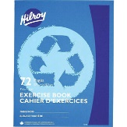
9 x 7 ½ Plain – ½ Interlined exercise book | 3 | Hilroy - Green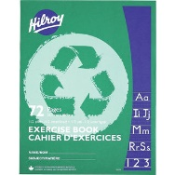
9 x 7 full interlined exercise book | 1 | Hilroy – Bluish or Purple 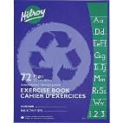
High quality HB pencils | 12 | 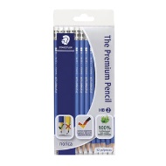
Pink eraser | 3 | 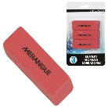
12pk. Crayola Pencil Crayons | 1 | 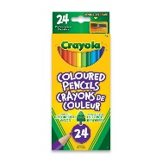
24 pk. Crayola Crayons | 1 | 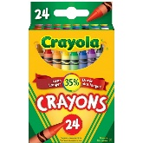
8pk. Crayola BROAD tip markers | 1 | 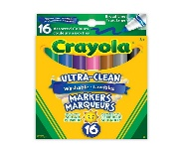
High Quality plastic pencil box | 1 | 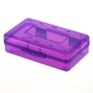
Duotangs- Asst. Colours | 6 | 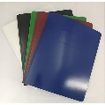
Kleenex- 100 box | 2
Highlighters- different colors | 2 | 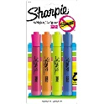
Fine Tip Dry Erase Markers- BLACK ONLY | 5 | Expo brand 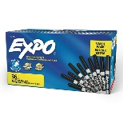
Indoor Running Shoes | 1 pair
If your child runs out of supplies throughout the year, you will be asked to provide more.

Please label with your child’s name on runners and items.
Thank You

