MMES SCHOOL SUPPLY LIST FOR GRADES THREE-FOUR
ITEM | Quantity | Description
9 x 7 ½ Plain – ½ Interlined exercise book | 3 | Hilroy - Green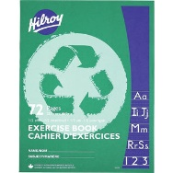
9 x 7 full interlined exercise book | 1 | Hilroy – Bluish or Purple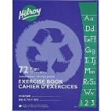
High quality HB pencils | 24 | 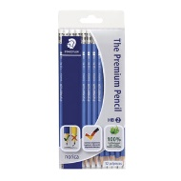
High quality eraser | 2 | 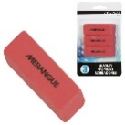
12pk. Crayola Pencil Crayons | 1 | 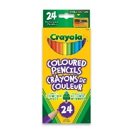
12pk. Crayola FINE tip markers | 1 | 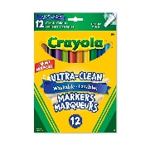
Two hole pencil sharpener – good quality | 1
High Quality plastic pencil box | 1 | 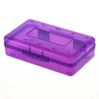
Duotangs- Asst. Colours | 6 | 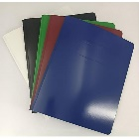
Kleenex- 100 box | 2
Twin Pocket Portfolio | 4 | 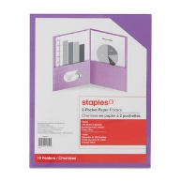
Fine Tip Dry Erase Markers- BLACK ONLY | 5 | Expo brand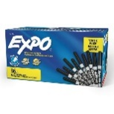
Indoor Running Shoes | 1 pair
40 gr. Glue Stick | 2 | 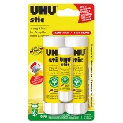
If your child runs out of supplies throughout the year, you will be asked to provide more.

Please mark you childs name on all supplies and inside running shoes.

