MMES SCHOOL SUPPLY LIST FOR GRADES FIVE - SIX – SEVEN CHECK BOTH SIDES OF PAPER
ITEM | Quantity | Description
3 Hole punched sheet protectors | 4 sheets | 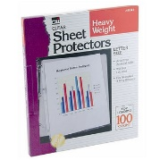
200 pk. Lined paper | 1 | 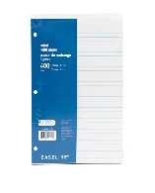
1” Plain Binder | 1 | 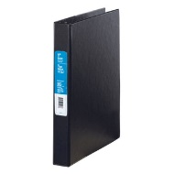
9 x 7 interlined exercise book | 1 - Gr. 5 only | Hilroy or Envilo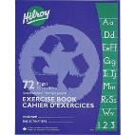
9 x 7 ½ plain – ½ ruled exercise book | 1 – Gr. 5 only | Hilroy or Envilo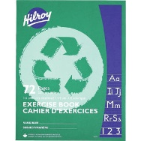
High quality HB pencils | 24 | 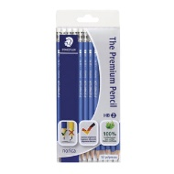
Twin Pocket Portfolio | 4 | 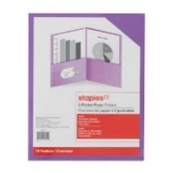
High Quality Eraser | 2 | 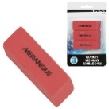
24 pk. Crayola Pencil Crayons | 1 | 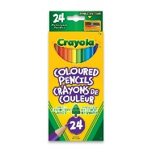
12 or 24 pk. Crayola Fine Tip Markers | 1 | 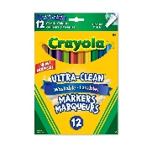
12 or 24 Crayola watercolour palette (paint) | 1 - | 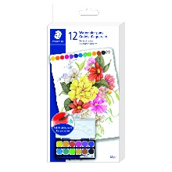
High Quality plastic pencil box | 1 | 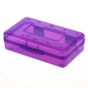
Duotangs- Asst. Colours | 6 | 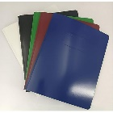
Kleenex- 100 box | 2
Two hole pencil sharpener – Staedler | 2
Fine Tip Dry Erase Markers- BLACK ONLY | 4 | Expo brand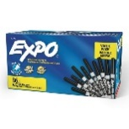
Indoor Running Shoes | 1 pair
5 tab binder dividers | 1 pkg | 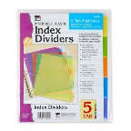
Water Bottle | 1
Daily Planner Book | 1 | 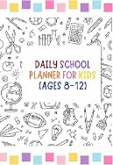
Pens – black, blue, red | 2 of each
40. gr Glue Stick | 2 - Gr. 5 Only | 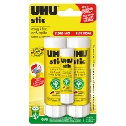
If your child runs out of supplies throughout the year, you will be asked to provide more.

