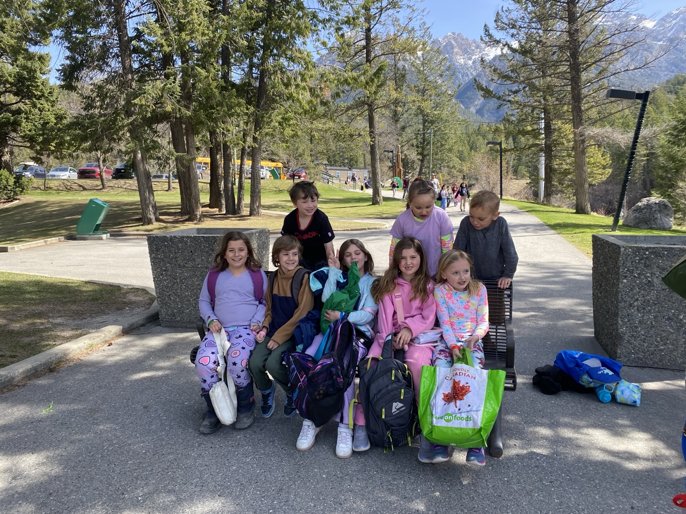

September 2025

SCHOOL SUCCESS PLAN

Martin Morigeau Elementary School

|  |  |
| --- | --- |
| Principal Message | |
| Martin Morigeau Elementary School is a rural K-7 school located on the traditional, unceded territories of the Ktunaxa and Secwépemc peoples. Canal Flats is also a chosen home for many members of the BC Métis Nation and 35% of our students identify as Métis.  The staff at MMES are committed to student engagement and working with community partners for inclusive, meaningful learning.  We strive for genuine connection to each other, the learning process, and our community.    Teachers, educational assistants, support staff, our Indigenous Education Support Worker, and the principal have collaborated to develop this plan. We meet regularly to review recent data and monitor our progress toward our goals. As we review our progress, we will adjust our approach to meet the dynamic needs of our students and staff.  Through Spring 2025 data review, teachers and support staff noted students have become more engaged with community resources and are demonstrating a clear connection and pride in their community. There is still work to do to improve student’s feeling of pride in their schoolwork and many students are not yet demonstrating proficient performance in literacy or numeracy. This year we plan to connect the success of our community connections with our need to advance literacy and numeracy performance.  Progress toward the School Success Plan is shared with the Parent Advisory Council throughout the year and updates are published on our school website. Feedback received is considered as support for the development of the annual plan.    Crystal Woodworth |  |

|  |  |
| --- | --- |
| school demographics | |
| Staff  3 Full-time teachers   * Learning Services Teacher (part-time) * Teacher-Librarian (part-time)   1 Part-time teacher  3 Education Assistants  1 Indigenous Education Student  Support Worker (part-time)  1 Admin Assistant  1 Principal | Students  63 students   * 30 Indigenous students |
| Grades  1 K-1- 2  1 Grade 3-4-5  1 Grade 5-6-7 |  |

|  |  |  |
| --- | --- | --- |
| Vision | Mission | |
| Our vision is to have a school where children flourish and reach their full potential as knowledgeable, caring, resilient, and contributing members of a global community. | Our mission is to meet the needs of each student through hands-on, experiential, place-based learning connected to our beautiful community. | |
| Values | | |
| At MMES we value:  **Curiosity** - having interest in learning new things.  **Community** – having a sense of belonging and care.  **Character** – being trustworthy and reliable. | |  |

|  |  |  |  |  |
| --- | --- | --- | --- | --- |
| Thematic narrative | | | | |
| In the 2024-25 school year, MMES focused on **connection**. We strived to have students feel connected to their community through accessing community resources and developing community partnerships to support place-based learning. We strived to have students feel connected to their learning through clear and ongoing communication of learning intentions and supporting students to develop learning goals and “I can” statements that reflected their understanding of what they were learning, why they were learning about it, and indicators of success.  We saw an improvement in school-wide attendance through the 1st half of the year as students reported that they didn’t want to miss special community projects and community supported sports programs after school. Community members also reported increased engagement by our students at community events such as community dinners, movie nights, and public skating. Additionally, there is increased student interest in participation in the school wolf pack leadership team. In 24/25 there were 7 leadership members, and on our school survey this spring, 38 students expressed interest in joining the leadership team for the 25/26 school year. The MMES PAC were particularly pleased with the increased community engagement projects and hoped to see this continue as well as a focus on outdoor learning.  Student surveys have shown an increase in student awareness of what is expected of them, why they are learning specific skills, and the importance of setting goals. Most students were able to set personal goals related to core competencies, but teachers recognized that setting meaningful academic goals is ongoing work and there was a decrease in reports of feeling proud of their work.  Our data shows that there are many students who are not yet achieving a proficient level assessment in any literacy or numeracy collected data - including on report cards, district, and provincial assessment measures. 19% of students are never achieving proficient in numeracy tasks, and 51% of students are never achieving proficent in literacy tasks. Students who identify as Indigenous are showing lower academic achievement and attendance overall.  Capitalizing on the success of our community connection theme from 24/25, Martin Morigeau Elementary School staff will focus on refining their community connections work by advancing their skills of integrating Indigenous content and Ways of Knowing into their practice. For 25/26, our focus will be on imbedding more Métis culture and resources into classrooms. In addition, the community connections model will extend into our literacy and numeracy work. Students will participate in a weekly school-wide “reading” and “number” buddies’ program with peers and invested community volunteers.  Goal – To improve proficiency in literacy, numeracy, and social responsibility. | | |  | |
| equity, Diversity and Inclusion Goal – To improve school engagement and attendance outcomes for our Indigenous students. | | |
| Inquiry If students see themselves in school activities and classroom learning, will they be more likely to attend school? | Action Staff will celebrate the cultures of the students in our school and specifically learn more about Metis culture by participating in 3 learning modules with the Metis Nation of BC. | |
| Data and Monitoring  * Monthly attendance records for Indigenous students * Monthly participation of Indigenous students in Wolf Pack Leadership initiatives   Resources:  BC Metis Nation  Jenny Reid – District Principal of Indigenous Learning and Equity | | |

|  |  |
| --- | --- |
| success for each learner Goal – To improve proficiency indicators in collected data of numeracy and literacy. | |
| Inquiry If teachers facilitate weekly school-wide reading and number buddies’ programs that integrates a community of learners approach, will we see increased levels of proficiency across our collected data? | Action Teachers will establish reading and number buddies with students across all grades and invite community volunteers to participate in the program. Each student will keep personal reading and number journals to reflect on their progress. |
| Data and Monitoring  * Conferencing with students and monitoring reading and numeracy journals for increased confidence and pride in skills. * Classroom based assessments (formative and summative) – report on literacy and numeracy progress at monthly collaborative response meetings. * Diagnostic assessments: PM Benchmarks/ F&P, PBLA, SNAP, District Numeracy Assessment, FSA, DWW, writing samples. * Report card proficiency indicators. * Community volunteer participation. | |

|  |  |
| --- | --- |
| Growing Capacity of Self and Others Goal – To improve staff capacity to integrate Metis resources and Ways of Knowing into classroom and school culture. | |
| Inquiry If staff learn more about Metis culture and related school resources, will this influence their classroom practice? | Action All teachers will participate in 3 learning modules with the Metis Nation of BC and integrate their learning into weekly classroom activities.  Wolf Pack Assemblies will highlight an aspect of Metis culture. |
| Data and Monitoring  * Inclusion of Metis related approach or content in Monthly school slide shows. * Frequency of Metis related content at Wolf Pack Assemblies * Teacher monthly self-report of progress toward inclusion of Metis content and Ways of Knowing.   Resources:  BC Metis Nation  Jenny Reid – District Principal of Indigenous Learning and Equity | |

|  |  |
| --- | --- |
| Stewardship for the Future Goal – To demonstrate that it takes a community to support children’s development in all areas, including literacy and numeracy. | |
| Inquiry If teachers introduce literacy and numeracy as social and community building opportunities by interacting with mixed grade partners and community resources during their weekly reading and number buddies’ program, will students show a growing sense of responsibility toward their learning? | Action All staff will engage students in weekly school-wide reading and number buddies’ programs that includes community volunteers to demonstrate that literacy and numeracy matters to the community. |
| Data and Monitoring  * Monitoring student reading and numeracy journals. * Classroom based assessments (formative and summative) – report on literacy and numeracy progress and attitudes at monthly collaborative response meetings. * Assessments: FSA, PM Benchmarks, F&P, PBLA, SNAP, District Numeracy Assessment, DWW, writing samples. * Report card proficiency indicators. * Community volunteer participation.   **Resources**  Glenn Goslin  Kristin Insull  MMES PAC | |